Урок английского языка в Музее Победы для инженерных классов
War Effort: Engineering
Рабочий лист

Introduction
Sum up the role of the Soviet Union in WWII based on what you’ve learnt in no more than 3 sentences.
Share and compare your ideas.
Task 1
Study the quotes by W. Churchill (Group 1) and F.D. Roosevelt (Group 2) on the walls of the Hall of Historical Verity. Are any of their ideas similar to yours?
Translate the quotes into English.
____________________________________________________________________________________________________________________________________________________________________________________________________________________________________________________________________________________________________________________________________________________

Use the QR-code to compare your translation to the original quotes. To what extent do the texts differ?

Group 1
Group 2
Make a list of the vocabulary from the original quotes that you lacked in your translations:
________________________________________________________________________________________________________________________________________________________________________________________________________________________________________________________________________________________________________________________________________________________________________________________________________________________

Add the vocabulary you find most useful to the Glossary.

What are the key points that Churchill and Roosevelt make in their speeches on the role of the USSR in WWII?

Task 2
Study the Soviet propaganda posters in the Hall of Historical Verity. What are their key messages?
Use the QR-code or the link below to see American and British propaganda posters. Identify the ones addressing engineers. What messages do they convey?
https://drive.google.com/drive/folders/1Rjv7l--qv_9P63PUrqi8pjK4LVug_609?usp=sharing
Pick one of the posters to compare and contrast with the Soviet poster of your choice. Use the following plan:
• briefly describe both posters;
• say what they have in common;
• say in what way they are different;
• say which one you find more impressive and explain why.
Do the task in pairs. Listen to your partner and comment on his/her talk. Mention:
- if you would add any information;
- if you agree with the conclusion; why/why not.

Task 3
Enter the Feat of the army hall.
Read the inscription on the wall. What was the role of engineers in winning the war?
Compare your ideas with the following passage. Complete the text by inserting the appropriate words into the gaps.
cleared / destroyed / destroying / diverting / fixed / traversing

During World War II, Army engineers placed floating and later _____ bridges across the rivers of Italy, France, and Germany, supporting hotly contested crossings of the Rapido, Roer, and Rhine rivers. Engineer troops prepared and developed beaches for assault landings, both in Europe and the Pacific. On the beaches of Normandy, engineer troops, operating under heavy enemy fire, _____ lanes for landing craft by _____ the mine-bearing steel structures that the Germans had implanted in the intertidal zone and bulldozed roads up the narrow draws through the cliffs lining the beaches. During the Battle of the Bulge, quick engineer actions _____ critical bridges in the path of advancing German forces, slowing and _____ them while Allied forces regrouped. The engineers also opened road connections _____ the long wilderness reaches between the southern Canadian road net and interior Alaska and between British-ruled Assam Province in India and Yunnan Province in southwestern China.
(from https://www.usace.army.mil/)
Add the most useful vocabulary to your Glossary.

What other function extremely important in times of war depends on the efforts of engineers and scientists?

Task 4
Study the exhibition of weapons. Find at least one weapon belonging to each of the categories:
- developed by Soviet engineers;
- captured as trophies;
- obtained through the Lend-Lease programme.
What do you know about the Lend-Lease policy?

Task 5
Watch a short video lecture by the History channel to learn more.
https://drive.google.com/file/d/1BOM5QwlB42EJNmCS5EaMUtZAIfaevZLL/view?usp=sharing
For each task 1 – 6, choose the best answer.
- The Lend-Lease Act initially regulated the conditions of weaponry provision between…
- the USA and the UK.
- the USA and the USSR.
- the UK and the USSR.

- According to the Neutrality Act, Britain…
- could not receive weapons from the US under any circumstances.
- could only get weapons from the US by paying cash and organizing transportation.
- could get weapons from the US on various terms.

- Why were some Americans against selling weapons to other countries?
- It could give unlimited power to the president.
- It would give more power to the president to participate in other countries’ wars.
- It could ruin the US economy.

- The Lend-Lease Act was devised as a way to…
- support war action without risking American citizens’ lives.
- avoid supporting any side in the war.
- earn more money for the state budget.

- As a result of signing the Act,
- only Great Britain received military support from the US.
- Great Britain, Russia and China received military support.
- a large number of countries received US military support.

- The Neutrality Act…
- prevented the USA from interfering till the end of the war.
- was cancelled when the Lend-Lease Act was signed.
- became irrelevant because of the attack on the USA.

Task 6
Look through the collection of weapons in the images. Find them in the museum exhibition and write their names in English.
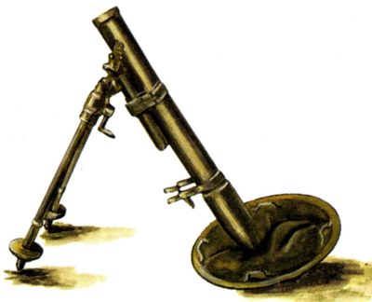 | _____________________________________
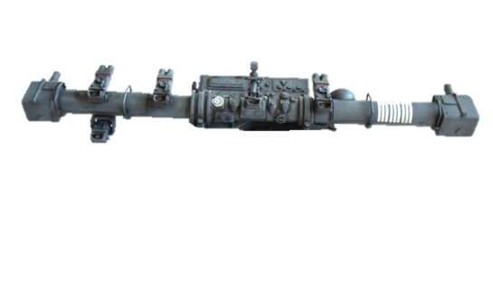 | _____________________________________
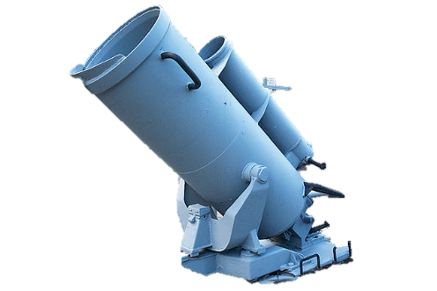 | _____________________________________
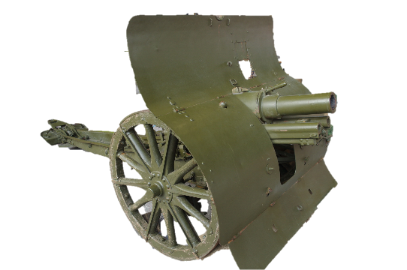 | _____________________________________
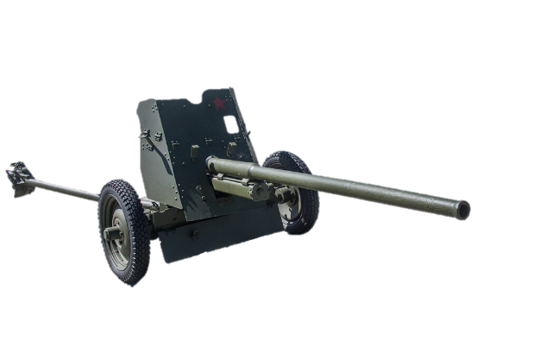 | ____________________________________

Play a guessing game:
Student A has to describe a weapon without naming it.
Useful words and phrases:
ammunition
barrel
calibre
cannon
carriage
combined
compared to
employed by
equipped/fitted with
to fire
mobile
a (wide) range / have a range of
used by/for
weight / to weigh
wheel

Student B needs to guess which one is being described. Student B can ask clarification questions.
e.g. What is it used for? How much does it weigh?

After Student B identifies the right weapon, swap roles.
Look through tasks 4 to 6 again and work on your Glossary.

Task 7
Return to the Hall of Historical Verity.
Find the infographics titled Freedom for the West, Salvation for the East.
Write a report based on the presented data and add a section on the contribution of engineers based on what you’ve learnt during the day.
Use the following plan:
– make an opening statement on the subject of your report;
– summarise the information by selecting and reporting the main features;
– make comparisons where relevant;
– give an overview of the engineers' contribution to the war effort;
– draw a conclusion.

Check out additional tasks in the Case files.

